Child Plus Instructions >

Verify Attendance/Meal Count Record Data
The Attendance/Meal Count data is recorded by the teaching staff. Family Workers (FW) will receive the Attendance/Meal Count after class each Friday or within 2 days after the end of the month for state classrooms. The FW must verify that all the information is complete, accurate and that a reason for absence code is documented for every absence. (See chart and definitions below)

Excused | Unexcused | Non‐Scheduled
Appointment | No Show, No Call | NonSched: See Notes
BIOC: See Notes | Other: See Notes | NonSched: Lack of Staff
Court Ordered Visitation |  | NonSched: Offsite Learner
Family Emergency: See Notes |  | NonSched: Connections:  Home Base Program
Lice
Other: See Notes
Sick (see Keep Me Home chart)
No Transportation

** See Notes: FW, Receptionist, HT/SS must enter reason for absence in the Attendance note section of ChildPlus

Definition of Reason for Absence

Best Interest of Child (BIOC) – Limited to 10 days per program year. Best Interest of Child (BIOC) days are considered excused absences.

For example:

- Vacation/Out of town
- Stay home with visiting relatives
- Special time with friend
- Special event (i.e., birthday or religious holiday)
- Others clearly in the best interest of thechild

Family Emergency: See Notes – is used when a family is experiencing an unexpected emergency requiring the family members action that results in an absence.
For example:
- Mom was called in to work and cannot bring child to school
- Family’s pipes are frozen, and family cannot bring child to school
- Illness of sibling
- House Fire
- Natural Disasters
- Power shut offs
- Death of immediate family member
(Always document reason for Family Emergency in Attendance Notes in ChildPlus)

Sick:
Refer to the Health and Safety section of the Parent Handbook, under illness and daily health check for examples of illnesses.
If the enrolled child’s parent is ill or has a medical emergency issue, this can be coded as “Sick” for the child.

Non‐scheduled: See Notes
Is used when circumstances prohibit a child from attending class and the absence is directly related to a SHS issue or plan.
Examples:
- A child needs a special needs aide and SHS is in the process of hiring. If the child cannot attend until the special needs’ aide is hired, we may use the Non‐scheduled code for this absence.
- Special needs aide is absent/ill.
- Child is enrolled in Connections Program and participating in the home base option where the child is missing school days as part of a set plan.
(Always document reason for Non‐scheduled in Attendance Notes in ChildPlus)

No Transportation – is used when an absence is related in any way to vehicle issues. For example:
- Family does not have gas or gas money
- Family’s vehicle is not running
- Family has one vehicle, and one parent has the vehicle at work.

Unexcused Absences
For example:
- Child did not feel like coming to school and is feeling well
- Parent or child overslept
- Any absence not falling in the excused category

Classroom closure reasons are entered by FW, Receptionist, or HT/SS.

Cancelled | Closed | Holiday | Teacher Workday
Unexpected cancellation of class/services: Low staff, no power/ water  Enter reason in classroom notes | Non‐holiday days agency does not provide services: additional days for Winter Break, Spring Break, Thanksgiving | Federal Holidays class does not operate | Staff Development/ Training days class does not operate
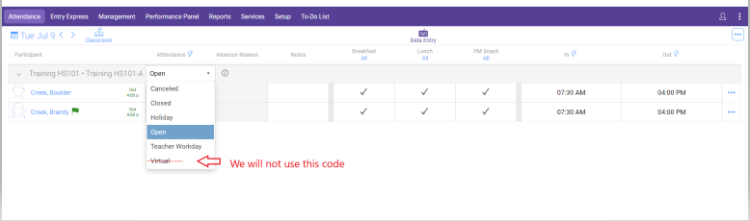

Enter Attendance/Meal Count Record in Child Plus
The Attendance/Meal Count Record data is entered into Child Plus Online by the Family Worker, Receptionist, Head Teacher, or Site Supervisor on a weekly basis. Once the data is entered for the week, run the Childplus #2310 Daily Attendance Report to verify the data entry for accuracy.
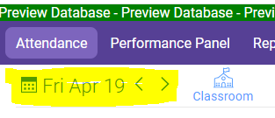
From Services > Click on the “Attendance” tab
- In the upper left corner, Using the calendar, click on the date for which attendance and meal counts are to be entered.
- A list of enrolled participants is displayed. Complete the attendance (see Absence Chart and Definitions in this SOP) and meal counts for every child on that day (notice that Child Plus defaults to everyone being present and eating every meal).
- Uncheck all meals that students have not participated in
- Press the save icon in the top right corner.

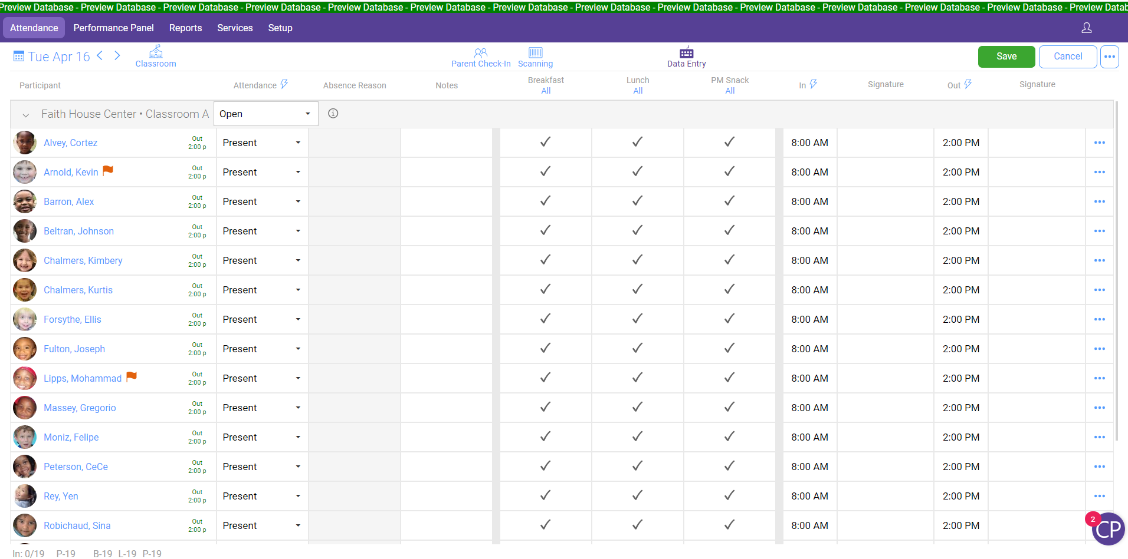
[Image: Enter Attendance‐Meal Count Record in Child Plus > 1SelectSiteClassroomandDate.png]

Entering Non-Participant Meals (staff and parent meals)
- Next to the classroom name on the attendance data entry screen press the symbol.
- After pressing this you can change the classroom status (if class unexpectedly is closed), add notes, count and mark nonparticipant meals under the Non-CACFP Status, only the Breakfast, Lunch, and PM Snack sections are required to be filled.
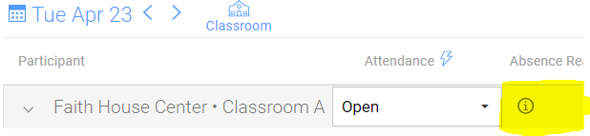
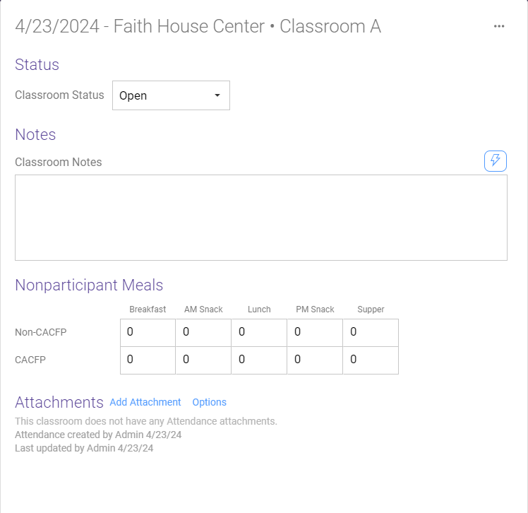
- Repeat the steps above for all days that are completed on the Attendance/Meal Count Record.

Verifying Data Entry for Accuracy

After all attendance/meal record data is entered into Child Plus for the week, verify the accuracy of the entry in Childplus.

- Print the #2310 report in Childplus to the corresponding week (see SOP)
- Compare attendance and meal totals on the original meal count to the #2310 report to verify the accuracy of the entry; correct errors as needed.
- When completed (all date entry has been verified), sign the bottom right corner of the attendance/meal count.
- Make a copy of the attendance/meal count record and #2310 report for your records
- Scan the copies to the Meal Count folder and send the original meal count to the Food Service Coordinator.

